HONORS CHEMISTRY • UNIT 1
Atomic Structure
Everything in the universe is built from a few kinds of tiny particles. Learn what they are, how we found them, and how to count them.

TEACHER EDITION
Everything in a light-gray box or cell is an answer or model response. Teacher notes (misconceptions, demo ideas, discussion prompts, sources) appear in the heavy-bordered boxes labeled TEACHER NOTE. The pages follow the student packet, so they line up closely.

What we will learn
1.1 | Atomic structure & properties
1.2 | Atomic history: how we know what atoms look like
1.3 | Isotopes & average atomic mass
1.4 | The mole, Avogadro’s number & molar mass
★ | Extra practice & unit review

By the end of this unit I can…
• Name the three subatomic particles and state the charge, relative mass and location of each.
• Use atomic number, mass number and charge to find protons, neutrons and electrons in atoms, isotopes and ions.
• Describe the key experiment and conclusion of Dalton, Thomson and Rutherford, and how the model of the atom changed.
• Explain why atomic masses are not whole numbers and calculate average atomic mass from isotope data.
• Use the mole as a bridge between particles and grams (Avogadro’s number and molar mass).
• Interpret lab data (mass-spectrometer graphs, balance readings, crucible data) to support a claim about atoms.
Unit at a glance (teacher)
Topic | Suggested pacing | Depth the homework expects
1.1 Atomic structure | 1–2 days | Particles, location, what each controls; label an atom; fill isotope tables; ions (protons vs. electrons).
1.2 Atomic history | 1–2 days | Conservation of mass with Dalton; refute “indivisible”; Thomson’s evidence & model; Rutherford’s prediction, result and conclusion.
1.3 Isotopes & atomic mass | 1–2 days | Define isotope; why masses are decimals; weighted-average calculations; identify the element; count atoms of each isotope in 1 mol.
1.4 Moles & molar mass | 1–2 days | Mole as a counting unit; molar mass from the periodic table; atoms ⇄ moles with dimensional analysis.

TEACHER OVERVIEW
Big picture. Students tend to memorize particle facts but not the *reasoning* behind them. The homework asks for evidence (“what did Thomson observe that told him the particle was negative?”), so the packet keeps asking “what was observed → what was concluded.”
Misconceptions to watch for:
• Mass number = atomic mass (they are close, not the same).
• Ions form by changing protons (they only change electrons).
• “The atomic mass is a decimal because of electrons.” (It is a weighted average of isotope masses.)
• A mole of anything has the same mass. (Same *number* of particles, different mass.)
• Rutherford “discovered the proton” — he discovered the nucleus.
• Calculating average atomic mass by averaging the isotope masses without weighting them.

IMAGES
Image spots: figures from the homework packet (the labeled atom, the mass-spectrometer graph, the Rutherford diagram) fit in the framed IMAGE GOES HERE boxes. All other diagrams in this packet were drawn to be printed in black and white.

TOPIC  1.1 | Atomic Structure & Properties  Protons • neutrons • electrons • ions

BIG IDEA
Every atom is made of just three particles. The number of protons decides which element it is; the neutrons add mass; the electrons decide the charge and how the atom bonds.

Key vocabulary — write each definition in your own words
Term | Definition (your words) | Example / sketch
Atom | The smallest unit of an element that still has the properties of that element. Made of a nucleus (protons + neutrons) surrounded by electrons. | A gold atom: 79 protons.
Proton | A positively charged particle (+1) found in the nucleus. The number of protons is the identity of the element. | Carbon always has 6 protons.
Neutron | A particle with no charge found in the nucleus. Adds mass and helps hold the nucleus together. | C-12 has 6 neutrons; C-14 has 8.
Electron | A negatively charged particle (−1) with almost no mass found in the electron cloud outside the nucleus. Controls the charge of an atom and how it bonds. | A neutral sodium atom has 11 e⁻.
Nucleus | The tiny, dense, positively charged center of the atom. Holds the protons and neutrons and almost all of the atom’s mass. | About 1/100,000 of the atom’s diameter.
Atomic number (Z) | The number of protons in the nucleus. It identifies the element. | Z = 17 is always chlorine.
Mass number (A) | The total number of protons + neutrons in one atom of an isotope. (A whole number.) | Fe-56: A = 56, so n = 56 − 26 = 30.
Ion | An atom (or group of atoms) that has gained or lost electrons so it has a net charge. The number of protons does not change. | Na⁺ lost one e⁻.

THINK OF IT LIKE… A STADIUM
If the nucleus were a marble sitting on the 50-yard line, the outer edge of the atom (the electron cloud) would be more than five football fields away. Almost all of an atom is empty space; almost all of its mass is in the marble.

THINK OF IT LIKE… A NAME TAG
The atomic number is the element’s name tag. Change a few neutrons or electrons and you still have the same element (a different isotope, or an ion). Change the number of protons and you have a completely different element.

REAL WORLD
Alchemists spent centuries trying to turn lead (82 protons) into gold (79 protons). Chemical reactions only move electrons, so they can never change the number of protons. Only nuclear reactions can (you will meet those in the Nuclear unit).

Fill in the particle table
Particle | Symbol | Charge | Relative mass (amu) | Location in the atom
Proton | p⁺ | +1 | 1 | in the nucleus
Neutron | n⁰ | 0 | 1 | in the nucleus
Electron | e⁻ | −1 | ≈ 0 (1/1836) | outside the nucleus, in the electron cloud

What controls what?
CUES / KEY WORDS  Identity  Mass  Charge | COMPLETE EACH LINE AND EXPLAIN WHY  Identity is controlled by the number of protons (atomic number). Change it and the element changes.  Mass is controlled by protons + neutrons (the nucleus). Electrons are about 1/1836 of a proton, so they add almost nothing.  Charge is controlled by the difference between protons and electrons. Equal numbers = neutral atom.

1. Label the parts of the atom below (A–E).
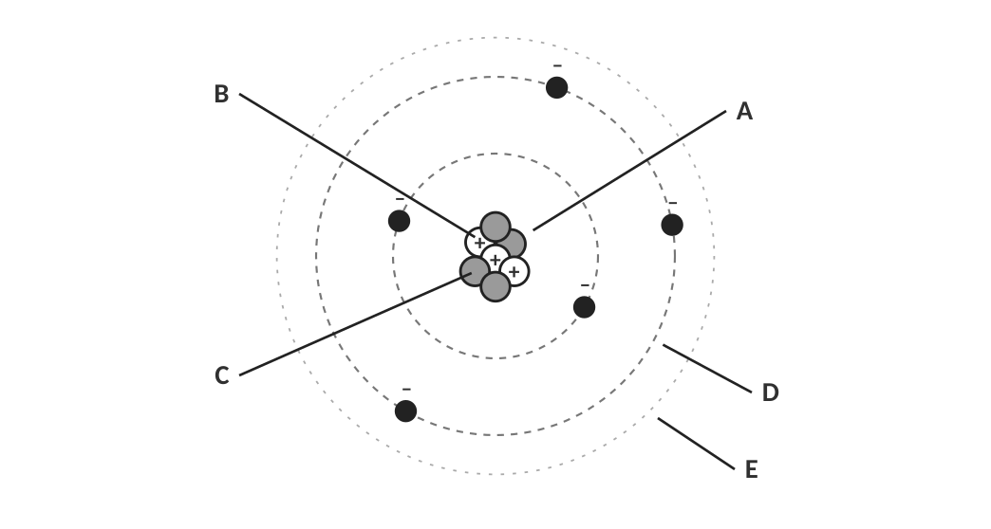
Diagram of a helium-like atom (not to scale).
A: nucleus B: proton C: neutron D: electron E: electron cloud (region where electrons are found)

[ IMAGE GOES HERE ]
Optional: the labeled-atom diagram from your Topic 1.1 homework

Nuclear symbols and hyphen notation
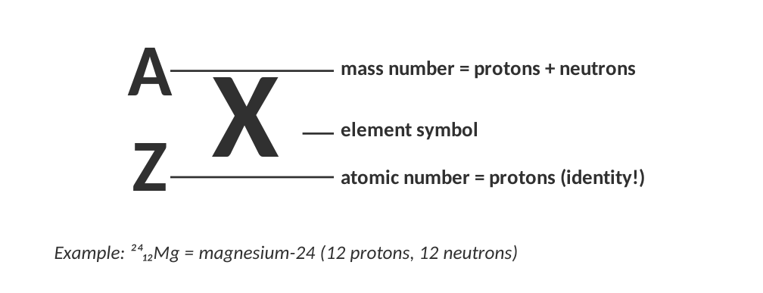
Two ways to name the same isotope.
WORKED EXAMPLE — COUNT THE PARTICLES
How many protons, neutrons and electrons are in a neutral atom of iron-56 (⁵⁶₂₆Fe)?

Protons = atomic number = 26.
Neutrons = mass number − atomic number = 56 − 26 = 30.
Neutral atom → electrons = protons = 26.

Answer: 26 p⁺, 30 n⁰, 26 e⁻
THREE RULES TO MEMORIZE
• protons = atomic number (Z) (always, even in ions)
• neutrons = mass number (A) − atomic number (Z)
• electrons = protons − charge (Na⁺: 11 − (+1) = 10 e⁻; O²⁻: 8 − (−2) = 10 e⁻)

WATCH OUT!
Mass number is a whole number you count. Atomic mass (on the periodic table) is a decimal average. They are not the same thing. You’ll see why in Topic 1.3.

Practice: fill in every blank
Isotope name | Nuclear symbol | Atomic # | Mass # | Protons | Electrons | Neutrons
carbon-14 | ¹⁴₆C | 6 | 14 | 6 | 6 | 8
copper-64 | ⁶⁴₂₉Cu | 29 | 64 | 29 | 29 | 35
uranium-238 | ²³⁸₉₂U | 92 | 238 | 92 | 92 | 146
argon-40 | ⁴⁰₁₈Ar | 18 | 40 | 18 | 18 | 22
silver-108 | ¹⁰⁸₄₇Ag | 47 | 108 | 47 | 47 | 61
oxygen-18 | ¹⁸₈O | 8 | 18 | 8 | 8 | 10
fluorine-19 | ¹⁹₉F | 9 | 19 | 9 | 9 | 10

TEACHER NOTE
Row 4 is given as e⁻ = 18 and n = 22 (neutral atom). Rows 5–6 show the table can be entered from any two numbers: encourage students to find the *first* thing they can calculate, then fill outward.

Ions: when the number of electrons changes
CUES / KEY WORDS  Ion  Cation  Anion | HOW DOES AN ATOM BECOME AN ION? WHAT ARE THE TWO TYPES?  An atom becomes an ion by gaining or losing electrons (never protons).  Cation = positive ion, formed when an atom loses electrons (more protons than electrons). Metals usually form cations.  Anion = negative ion, formed when an atom gains electrons (more electrons than protons). Nonmetals usually form anions.

THINK OF IT LIKE… A BANK ACCOUNT
Protons are the account’s fixed deposits; electrons are the cash you can add or take away. Losing electrons (cash) leaves the atom more positive; gaining electrons leaves it more negative. A tip to remember: cations are +itive (the t looks like a plus sign); anions have a negative charge.

Ion | Cation or anion? | Protons | Electrons | Gained or lost how many e⁻?
Al³⁺ | cation | 13 | 10 | lost 3
O²⁻ | anion | 8 | 10 | gained 2
K⁺ | cation | 19 | 18 | lost 1
N³⁻ | anion | 7 | 10 | gained 3
Ca²⁺ | cation | 20 | 18 | lost 2
Br⁻ | anion | 35 | 36 | gained 1

2. An ion has 26 protons and 23 electrons. What is its charge, and is it a cation or an anion? Name the ion (hint: look at the periodic table).
Charge = 26 − 23 = +3, so it is a cation: Fe³⁺ (iron(III) ion).

3. Explain why the mass of a Na⁺ ion is practically identical to the mass of a neutral Na atom, even though they are different particles.
The ion differs only by one electron, and an electron has about 1/1836 the mass of a proton. The mass is in the nucleus, which did not change.

4. A student says: "If I add a proton to a neutral oxygen atom I get an O⁻ ion." Correct the statement.
Adding a proton changes the element (oxygen → fluorine). Ions form only by gaining or losing electrons. Adding an electron to neutral oxygen gives O⁻.

LAB CORNER • Reading an element tile

Chemists read the periodic table like a label on a food package. Use the tile below for aluminum.
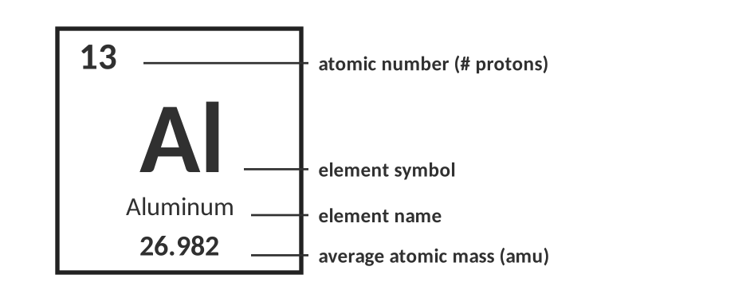
A typical periodic table tile.
Question | Your answer
Which number is the atomic number? How many protons does an Al atom have? | The whole number on top (13). 13 protons.
Which number is the atomic mass? Why isn’t it a whole number? | 26.98. It is a weighted average of the masses of all of aluminum’s naturally occurring isotopes.
How many electrons are in an Al³⁺ ion? | 13 − 3 = 10 electrons.
Most aluminum atoms have 14 neutrons. What is the mass number of that isotope? | 13 + 14 = 27 → Al-27.

TEACHER NOTE
This sets up Topic 1.3 (why 26.98?). Al is nearly 100% Al-27, which is why the decimal is close to 27.

Check for understanding
5. Which particle(s) contribute significantly to the mass of an atom?
A) electrons only
B) protons and neutrons
C) protons and electrons
D) neutrons and electrons

6. Two atoms have the same number of protons but different numbers of neutrons. They are…
A) different elements
B) isotopes of the same element
C) ions of the same element
D) impossible

TOPIC  1.2 | Atomic History  Dalton • Thomson • Rutherford • and the evidence behind each model

BIG IDEA
A model of the atom is only as good as the evidence behind it. Every time scientists did a new experiment and got a surprising result, the model had to change.

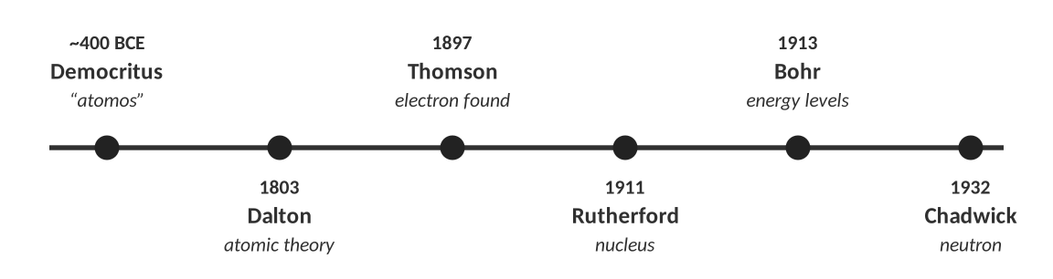
How our picture of the atom developed.
THINK OF IT LIKE… A MYSTERY BOX
Imagine a sealed shoe box with something hidden inside. You can’t open it, but you can roll marbles through it and see where they come out. If every marble goes straight through, the box is empty. If some bounce back, something solid is in there. Rutherford did exactly this with atoms, using alpha particles for marbles.

Dalton’s atomic theory (about 1803)
CUES / KEY WORDS  Atoms  Elements  Compounds  Reactions | WRITE EACH OF DALTON’S IDEAS IN YOUR OWN WORDS  1. All matter is made of tiny particles called atoms.  2. All atoms of a given element are identical to each other in mass and properties, and different from atoms of other elements.  3. Compounds form when atoms of different elements combine in simple whole-number ratios.  4. In a chemical reaction atoms are rearranged: never created, destroyed or changed into other kinds of atoms (law of conservation of mass).

Dalton’s idea | Does modern theory agree? Explain.
Atoms are indivisible (the smallest form of matter). | No. Atoms are made of protons, neutrons and electrons (and those are made of smaller particles). Nuclear reactions can even split atoms.
All atoms of an element are identical. | Not exactly. Isotopes of an element have different numbers of neutrons, so different masses.
Atoms are never created or destroyed in a chemical reaction. | Yes, for chemical reactions. (Nuclear reactions are different.)

LAB CORNER • The burning magnesium ribbon

A student burns magnesium ribbon in a crucible with a lid, then re-weighs the white powder. She repeats the experiment three times.
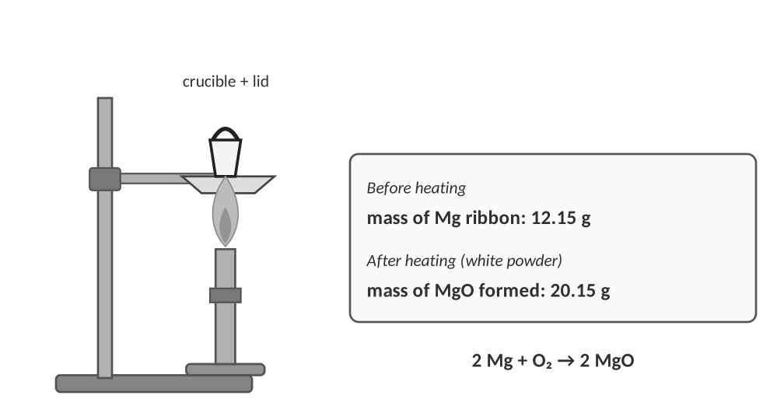
1. The solid’s mass increased. Use Dalton’s theory to explain where the extra mass came from, and calculate it for the first trial.
a. How many grams of oxygen combined with the 12.15 g of magnesium?
20.15 g − 12.15 g = 8.00 g of oxygen.

b. Explain the answer using one of Dalton’s ideas.
Atoms are not created or destroyed in a chemical reaction, only rearranged. The magnesium atoms combined with oxygen atoms from the air, so the product has the mass of both. Mass of reactants = mass of products (conservation of mass).

Trial | Mg used (g) | MgO formed (g) | O gained (g) | Mass Mg ÷ mass O
1 | 12.15 | 20.15 | 8.00 | 1.52
2 | 6.08 | 10.08 | 4.00 | 1.52
3 | 9.12 | 15.12 | 6.00 | 1.52

2. What pattern do you notice in the last column? What does it suggest about how magnesium and oxygen combine?
The ratio is constant (about 1.52 g Mg for every 1 g O). Magnesium and oxygen always combine in the same fixed mass ratio, which fits Dalton’s idea that compounds form from atoms in definite whole-number ratios (law of definite proportions).

3. Suppose white smoke escaped from the crucible when the lid was lifted and the student’s final mass was only 18.9 g. Does this break the law of conservation of mass? Explain.
No. The missing mass is MgO that left the crucible as smoke. Mass is still conserved, but the system was not closed, so the student didn't measure all of the product.

TEACHER NOTE
Mg is 24.31 g/mol and O is 16.00 g/mol, so the exact mass ratio in MgO is 24.31 : 16.00 = 1.52 : 1. The data are built from that ratio. A real crucible experiment also produces some Mg₃N₂ (Mg reacts with N₂ in air), which is a good “why isn’t our data perfect?” discussion.

Thomson: the electron (1897)
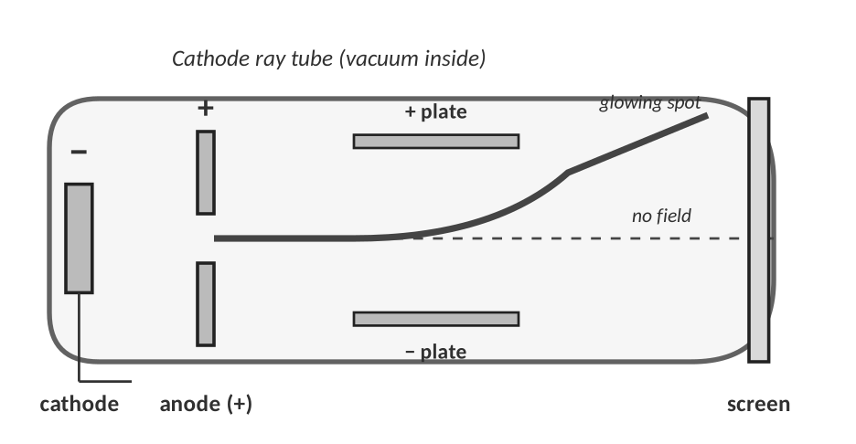
Cathode ray tube. Rays travel from the cathode (−) to the anode (+).
Observation | What Thomson concluded
A glowing ray travels from the negative electrode (cathode) to the positive end. | The ray is made of particles that come out of the metal.
When a positively charged plate is placed near the ray, the ray bends toward it. | Opposite charges attract, so the particles must be negatively charged.
The ray’s behaviour did not change when a different metal was used for the cathode. | These particles are in the atoms of all matter.
The particles were about 1/1800 as massive as a hydrogen atom. | They are smaller than an atom: atoms are divisible! Thomson named them electrons.

4. What evidence did Thomson use to decide the particle had a charge, and what was the sign of the charge?
The cathode ray was bent (deflected) by electric and magnetic fields. It bent toward the positive plate and away from the negative plate, so the charge is negative.

5. Thomson’s atom was electrically neutral but contained negative electrons. Describe his model, name it, and sketch it in the box.
The plum-pudding model: a sphere of diffuse positive charge (the pudding) with negative electrons (the plums) scattered throughout it. Overall neutral.

Sketch: a large circle shaded as positive 'pudding' with small dots marked − scattered inside.

LAB CORNER • Charged tape

A teacher sticks two strips of tape to a desk, peels them off, and holds them near each other. Strips of the same type repel each other. Strips of different types attract.
Pair | What happens | What does it show?
Top strip + top strip | repel | Same type of charge repels.
Bottom strip + bottom strip | repel | Same type of charge repels.
Top strip + bottom strip | attract | The two strips have opposite charges. There are two kinds of charge.

KEY RULE
Like charges repel. Opposite charges attract. You will use this rule to explain Rutherford’s experiment, bonding, ionization energy and nearly everything else in chemistry.

Rutherford: the nucleus (1911)
Rutherford’s team aimed a beam of alpha (α) particles (positively charged helium nuclei) from a radioactive source at an extremely thin sheet of gold foil, and used a screen to detect where the particles ended up.
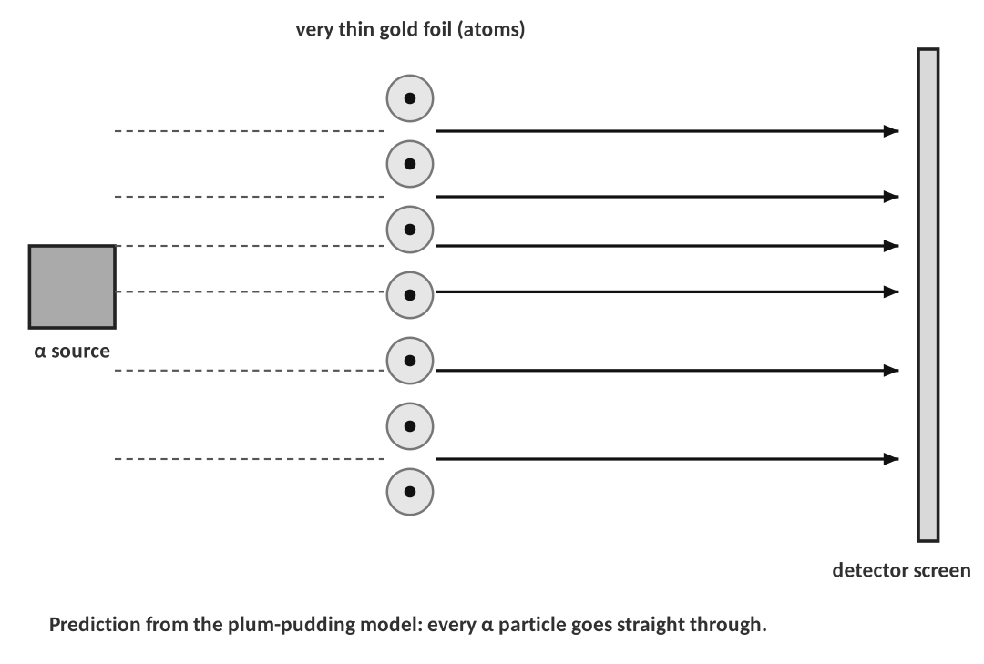
6. The plum-pudding model predicted every alpha particle would pass straight through. Why? (Think about the charge of the particles and how it is spread out in Thomson’s atom.)
In Thomson’s atom the positive charge is spread out evenly and the electrons are very light, so there is no concentrated charge strong enough to repel a fast, heavy alpha particle. It should plow straight through, like a bullet through a cloud.

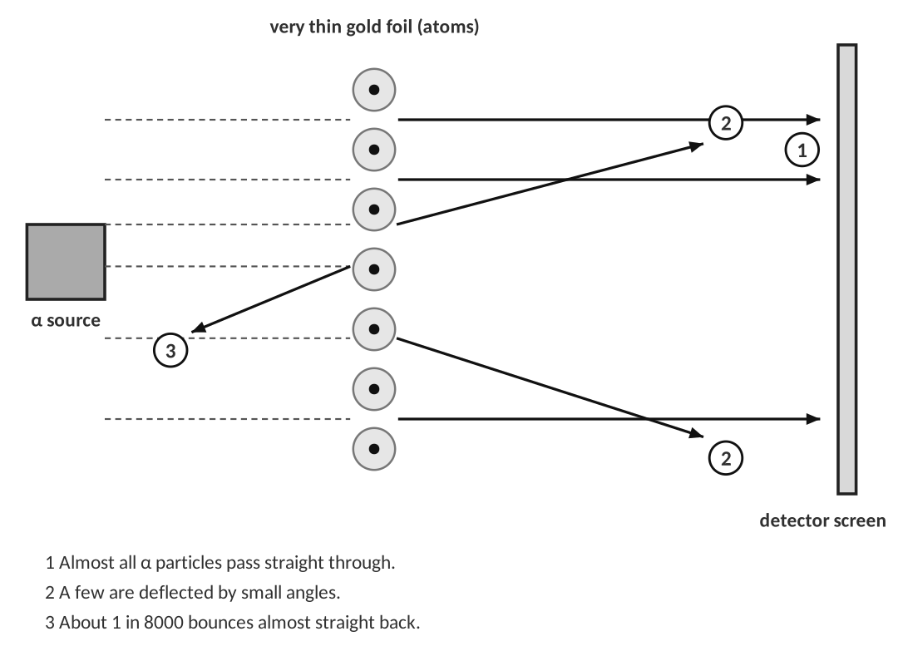
7. Describe the results of the experiment. Be specific about what happened to the alpha particles.
Most alpha particles passed straight through. A few were deflected at small angles, and a very few (about 1 in 8000) bounced almost straight back.

Observation | Conclusion about the atom
Most α particles passed straight through. | Most of the atom is empty space.
A few α particles were deflected. | There is a small positively charged region that repels the positive α particles.
1 in 8000 bounced almost straight back. | That charged region is tiny, very dense and has most of the atom’s mass: the nucleus.

THINK OF IT LIKE… SHOOTING AT A HAYSTACK
You fire 8000 bullets at a haystack. Almost all of them pass through, but about one bounces straight back. You would conclude that something small, hard and heavy is hidden in the hay. Rutherford later said it was as surprising as firing a huge artillery shell at tissue paper and having it come back at you.

8. A lab fires 2.4 × 10⁵ alpha particles at a gold foil. About how many would you expect to bounce back?
2.4 × 10⁵ ÷ 8000 = 30

Answer: ≈ 30 particles
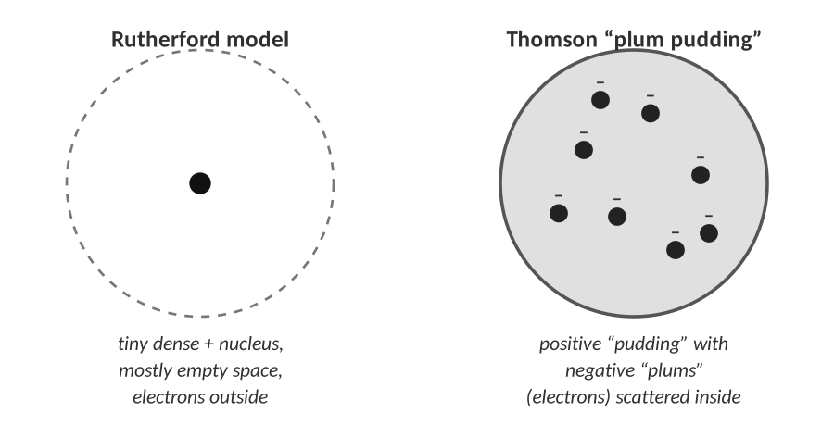
Thomson (left) and Rutherford (right)

9. Describe Rutherford’s new model of the atom and draw it. What did it fail to explain?
A tiny, dense, positively charged nucleus at the center that holds nearly all the mass, with electrons outside it in mostly empty space. It couldn’t explain why electrons don’t spiral into the nucleus, or what the extra mass in the nucleus was made of (later answered by Bohr's energy levels and Chadwick's neutron).

[ IMAGE GOES HERE ]
Optional: the Rutherford experiment diagram from your Topic 1.2 homework or an AP exam figure

After Rutherford
Scientist | Year | Contribution
Bohr | 1913 | Electrons travel in fixed energy levels (orbits) around the nucleus (Unit 2).
Chadwick | 1932 | Discovered the neutron, the neutral particle in the nucleus that explains the missing mass.
Schrödinger and others | 1920s | Quantum-mechanical model: electrons are found in clouds of probability (orbitals), not on fixed paths.

Check for understanding — match the evidence to the scientist
Evidence | Scientist | Model it supports
Cathode ray bends toward a positive plate | Thomson | Plum pudding: electrons inside a positive sphere
Some α particles bounce straight back from gold foil | Rutherford | Nuclear model
Mass is the same before and after burning (closed system) | Dalton (and Lavoisier) | Atoms rearrange; never destroyed
Atoms of one element with different masses | Later work (Thomson / Aston); explained by Chadwick’s neutron | Isotopes

TOPIC  1.3 | Isotopes & Average Atomic Mass  Same protons, different neutrons • weighted averages • mass spectra

BIG IDEA
Atoms of the same element can have different numbers of neutrons (isotopes). The atomic mass on the periodic table is a weighted average of all the isotopes, which is why it is almost never a whole number.

Key vocabulary — write each definition in your own words
Term | Definition (your words) | Example / sketch
Isotope | Atoms of the same element (same number of protons) that have different numbers of neutrons, and therefore different mass numbers. | C-12, C-13 and C-14
Atomic mass unit (amu) | The unit for the mass of individual atoms. 1 amu is defined as 1/12 the mass of a carbon-12 atom (about the mass of one proton or neutron). | A carbon-12 atom has a mass of exactly 12 amu.
Percent abundance | The percentage of all the atoms of an element in nature that are a particular isotope. | Cl-35 is 75.77% of all chlorine atoms.
Average atomic mass | The weighted average of the masses of all of an element’s naturally occurring isotopes. It is the decimal number on the periodic table. | Chlorine: 35.45 amu
Mass spectrometer | An instrument that separates atoms by mass and shows the mass and relative abundance of each isotope. | A bar graph: mass on the x-axis, % abundance on the y-axis.

ISOTOPE NAMES
Isotopes are named with the element and the mass number: carbon-14 or C-14, also written ¹⁴₆C.
Hydrogen is the only element whose isotopes have their own names: protium (H-1, 0 n), deuterium (H-2, 1 n) and tritium (H-3, 2 n).

Isotope | Protons | Neutrons | Electrons (neutral) | Mass number
Mg-24 | 12 | 12 | 12 | 24
Mg-25 | 12 | 13 | 12 | 25
Mg-26 | 12 | 14 | 12 | 26

1. Which of the following pairs are isotopes of the same element? ¹²₆C and ¹⁴₆C; ¹⁴₆C and ¹⁴₇N; ³⁵₁₇Cl and ³⁷₁₇Cl
The first pair and the third pair (same number of protons, different mass numbers). C-14 and N-14 have the same mass number but different protons, so they are different elements.

Why isn’t the atomic mass a whole number?
THINK OF IT LIKE… YOUR GRADE IN A CLASS
Tests are worth 70% of your grade and homework is worth 30%. You average 90 on tests and 60 on homework. Your grade is not (90 + 60) ÷ 2 = 75, because the tests count more: 0.70 × 90 + 0.30 × 60 = 81. An element’s atomic mass is the same kind of average: each isotope “counts” in proportion to how common it is.

WORKED EXAMPLE — WEIGHTED AVERAGE
Boron has two isotopes: B-10 (10.013 amu → use 10 amu) is 19.9% abundant and B-11 (use 11 amu) is 80.1% abundant. Calculate the average atomic mass.

1. Change each percent to a decimal: 19.9% = 0.199; 80.1% = 0.801.
2. Multiply each mass by its decimal: 10 × 0.199 = 1.99; 11 × 0.801 = 8.811.
3. Add: 1.99 + 8.811 = 10.801 → 10.8 amu.

Answer: 10.8 amu (matches the periodic table)
THE RECIPE
Average atomic mass = (mass₁ × abundance₁) + (mass₂ × abundance₂) + … (write abundances as decimals; they add to 1.00)

WATCH OUT!
Never just add the masses and divide by the number of isotopes. A simple average treats a rare isotope as if it were as common as a common one.

LAB CORNER • Penny isotopes

Pennies minted before 1982 are almost pure copper; pennies minted after are mostly zinc with a thin copper coating. They look alike but have different masses, so they behave like two isotopes of “the penny.”
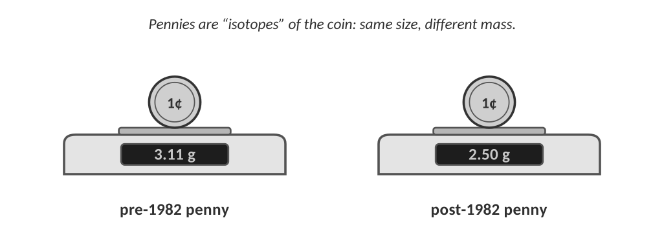
A student weighs a bag of 50 pennies by sorting them and counting. She finds 31 pre-1982 pennies and 19 post-1982 pennies.
Type | Number | Abundance (decimal) | Mass of one (g) | Abundance × mass (g)
Pre-1982 | 31 | 0.62 | 3.11 | 1.928
Post-1982 | 19 | 0.38 | 2.50 | 0.950

2. Calculate the average mass of a penny in this bag.
1.928 g + 0.950 g = 2.878 g → 2.88 g

Average mass: 2.88 g
3. Is any single penny in the bag actually 2.88 g? What does this tell you about the atomic mass of an element like chlorine?
No, every real penny is either 3.11 g or 2.50 g. The average is a calculated number that describes the whole collection. In the same way, no chlorine atom has a mass of 35.45 amu; the atoms are 35 amu or 37 amu and 35.45 is the average of all of them.

4. Is the average closer to the mass of the pre-1982 penny or the post-1982 penny? Why?
Closer to the pre-1982 penny (3.11 g), because there are more of them (62%). The more abundant type pulls the average toward its mass.

LAB CORNER • Reading a mass spectrum

A mass spectrometer ionizes atoms, speeds them up and bends their path with a magnet. Lighter ions bend more than heavier ones, so the instrument sorts the atoms by mass and counts how many of each arrive.
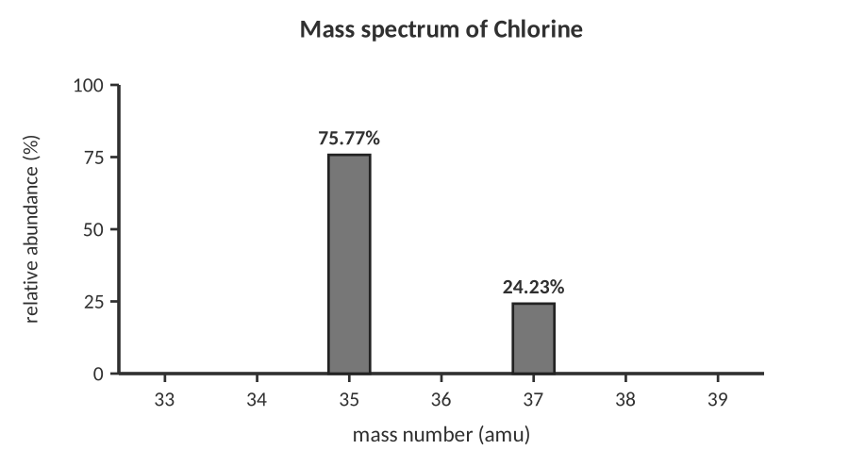
Mass spectrum of a sample of chlorine.
Question | Your answer
How many isotopes of chlorine are in the sample? | 2
What are their masses and abundances? | 35 amu: 75.77%; 37 amu: 24.23%
Without calculating, predict whether the average will be closer to 35 or 37. Why? | Closer to 35, since 35 is the more abundant isotope.

5. Calculate the average atomic mass of chlorine from the graph (use the mass numbers as the masses).
35 × 0.7577 = 26.520; 37 × 0.2423 = 8.965; sum = 35.48 amu

Average atomic mass: 35.48 amu
TEACHER NOTE
The periodic-table value is 35.45 because the *exact* isotope masses are 34.969 and 36.966 amu, not 35 and 37. The homework uses whole-number masses, so accept answers like 35.48. If students ask why the answer is slightly off, show them the exact-mass calculation.

6. In a sample of 1000 chlorine atoms, about how many are Cl-35 and how many are Cl-37?
1000 × 0.7577 ≈ 758 atoms of Cl-35; 1000 × 0.2423 ≈ 242 atoms of Cl-37.

[ IMAGE GOES HERE ]
Optional: the mass-spectrometer or carbon-isotope data table from your Topic 1.3 homework

Practice
7. Lithium has two isotopes: Li-6 (7.59%) and Li-7 (92.41%). Calculate the average atomic mass of lithium.
6 × 0.0759 = 0.4554; 7 × 0.9241 = 6.4687; sum = 6.9241

Answer (units & sig figs): 6.92 amu
8. Magnesium has three isotopes: Mg-24 (78.99%), Mg-25 (10.00%) and Mg-26 (11.01%). Calculate its average atomic mass.
24 × 0.7899 = 18.958; 25 × 0.1000 = 2.500; 26 × 0.1101 = 2.863; sum = 24.320

Answer (units & sig figs): 24.32 amu
9. An unknown element has two isotopes: one of mass 107 amu (51.84%) and one of mass 109 amu (48.16%). Calculate the average atomic mass and identify the element using your periodic table.
107 × 0.5184 = 55.469; 109 × 0.4816 = 52.494; sum = 107.96 amu → closest element on the table: silver (Ag, 107.87).

Answer (units & sig figs): 107.96 amu → silver (Ag)
10. Boron’s average atomic mass is 10.8 amu. Its two isotopes have masses of 10 and 11 amu. Without doing a full calculation, which isotope is more abundant and why? Then use algebra to find the percent abundance of the heavier isotope.
10.8 is much closer to 11, so B-11 is more abundant.
Let x = abundance of B-11 (decimal): 10(1 − x) + 11x = 10.8 → 10 + x = 10.8 → x = 0.80 → 80% B-11 (20% B-10).

Abundance of heavier isotope: ≈ 80%
11. Carbon’s atomic mass is 12.01 amu, very close to 12. What does this tell you about the abundance of C-12 compared with C-13 and C-14?
C-12 must be by far the most abundant isotope (98.9%). The average is pulled almost completely to 12.

REAL WORLD
Carbon-14 is radioactive. Living things take it in all the time; when they die the C-14 slowly decays, so measuring how much is left tells scientists how old a bone or a piece of wood is (radiocarbon dating). Iodine-131 is used in medicine to treat thyroid disease.

Check for understanding
12. Chlorine’s atomic mass is 35.45 amu. Which statement is true?
A) Every chlorine atom has a mass of 35.45 amu.
B) Chlorine is a mixture of isotopes, mostly with masses near 35 and 37 amu.
C) Chlorine atoms contain 35.45 neutrons.
D) The decimal comes from the mass of the electrons.

13. Two isotopes of the same element always have the same…
A) mass number
B) number of neutrons
C) number of protons
D) atomic mass

TOPIC  1.4 | The Mole, Avogadro’s Number & Molar Mass  Counting atoms by weighing them

BIG IDEA
Atoms are far too small to count one by one, so chemists count them in huge groups called moles. 1 mole = 6.022 × 10²³ particles, and the mass of 1 mole of an element in grams equals its atomic mass.

Key vocabulary — write each definition in your own words
Term | Definition (your words) | Example / sketch
Mole (mol) | The SI unit for an amount of substance: 6.022 × 10²³ particles (atoms, molecules or ions) of anything. | 1 mol of Na = 6.022 × 10²³ Na atoms.
Avogadro’s number | The number of particles in one mole: 6.022 × 10²³ particles/mol. | 2 mol C = 2 × 6.022 × 10²³ atoms.
Molar mass (g/mol) | The mass in grams of one mole of a substance. For an element, it is the same number as the atomic mass on the periodic table. | Carbon: 12.01 g/mol
Conversion factor | A fraction made from two equal quantities in different units, used to change units without changing the amount. | (6.022 × 10²³ atoms / 1 mol)

THINK OF IT LIKE… A DOZEN, A REAM, A GROSS
We already count by groups: a dozen eggs is 12, a ream of paper is 500 sheets. A dozen eggs and a dozen bowling balls contain the same *number* of objects but have very different *masses*. A mole is just a bigger group; a mole of carbon and a mole of lead both contain 6.022 × 10²³ atoms but have very different masses (12.01 g and 207.2 g).

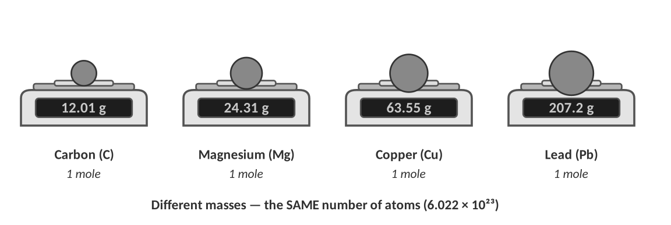
REAL WORLD
How big is a mole? If you could count one atom every second, it would take about 1.9 × 10¹⁶ years, roughly 1.4 million times the age of the universe, to count a single mole.
A mole of liquid water (18.02 g) is only about 18 mL, a little more than a tablespoon. That small amount holds 6.022 × 10²³ water molecules.

The mole is the bridge
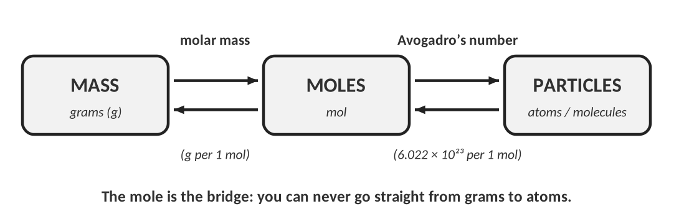
CUES / KEY WORDS  Mole → particles  Mole → grams | WRITE THE TWO CONVERSION FACTORS AND WHEN TO USE EACH  Particles ⇄ moles: use Avogadro’s number: 6.022 × 10²³ particles = 1 mol.  Grams ⇄ moles: use the molar mass from the periodic table: for carbon, 12.01 g = 1 mol.  To go from grams to atoms (or back) you must pass through moles.

Molar mass from the periodic table
Element | Molar mass (g/mol) | Element | Molar mass (g/mol)
Lithium | 6.94 | Copper | 63.55
Nitrogen | 14.01 | Silver | 107.87
Silicon | 28.09 | Gold | 196.97
Calcium | 40.08 | Lead | 207.2

Worked examples
WORKED EXAMPLE — MOLES → ATOMS
Convert 2.50 mol of carbon to atoms of carbon.

Start with what you are given and multiply by the conversion factor so that mol cancels:
2.50 mol C × (6.022 × 10²³ atoms C / 1 mol C) = 1.5055 × 10²⁴ atoms C

Answer: 1.51 × 10²⁴ atoms C
WORKED EXAMPLE — ATOMS → MOLES
Convert 5.15 × 10²³ atoms of sulfur to moles of sulfur.

Now the factor is flipped so that atoms cancel:
5.15 × 10²³ atoms S × (1 mol S / 6.022 × 10²³ atoms S) = 0.855 mol S

Answer: 0.855 mol S
SET-UP CHECK
Write the unit you have, then a fraction with that unit on the bottom so it cancels. The unit you want goes on top. If your units don’t cancel, flip the fraction.

LAB CORNER • A balance reading and the mole bridge

A student places a coil of copper wire on a balance. The reading is shown below.
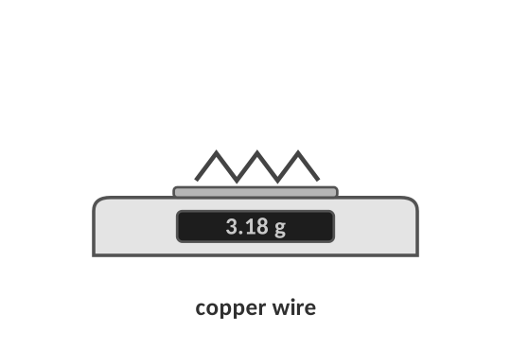
1. How many moles of copper are in the coil? How many copper atoms?
a. Convert the mass to moles (molar mass of Cu = 63.55 g/mol).
3.18 g Cu × (1 mol Cu / 63.55 g Cu) = 0.0500 mol Cu

Answer (units & sig figs): 0.0500 mol Cu
b. Convert the moles to atoms.
0.0500 mol Cu × (6.022 × 10²³ atoms / 1 mol) = 3.01 × 10²² atoms Cu

Answer (units & sig figs): 3.01 × 10²² atoms Cu
TEACHER NOTE
Carry extra digits until the end: 3.18 ÷ 63.55 = 0.050039… mol; × 6.022 × 10²³ = 3.013 × 10²² → 3.01 × 10²².

2. A sample contains 2.50 × 10²² atoms of zinc. What is its mass in grams? (Zn = 65.38 g/mol)
2.50 × 10²² atoms × (1 mol / 6.022 × 10²³ atoms) × (65.38 g / 1 mol) = 2.71 g

Answer (units & sig figs): 2.71 g Zn
WORKED EXAMPLE — ISOTOPES IN A MOLE
One mole of the unknown element from Topic 1.3 (isotopes 107 amu: 51.84% and 109 amu: 48.16%) contains 6.022 × 10²³ atoms. How many atoms of each isotope are in the sample?

107-isotope: 0.5184 × 6.022 × 10²³ = 3.12 × 10²³ atoms
109-isotope: 0.4816 × 6.022 × 10²³ = 2.90 × 10²³ atoms

Answer: 3.12 × 10²³ and 2.90 × 10²³ atoms
Counting by weighing (a lab technique)
You can’t count atoms, but you can count nuts and bolts by weighing them. A hardware store does this all the time.
3. A student weighs 25 identical steel nuts and finds the mass is 31.4 g. She then weighs a big bag of the same nuts and finds 502 g. About how many nuts are in the bag?
1 nut = 31.4 g ÷ 25 = 1.256 g
502 g × (25 nuts / 31.4 g) = 399.7 ≈ 400 nuts

Number of nuts: ≈ 400 nuts
4. How is this the same as using molar mass to count atoms? What plays the role of “25 nuts = 31.4 g”?
Both turn a mass into a count using a known mass-per-group. For atoms the group is the mole: 1 mole of copper atoms = 63.55 g. That molar mass plays the role of “25 nuts = 31.4 g.”

Molar mass of a compound (preview)
For a compound, add up the molar masses of every atom in the formula.
WORKED EXAMPLE — WATER
Find the molar mass of H₂O.

2 × 1.01 g/mol (H) + 1 × 16.00 g/mol (O) = 2.02 + 16.00 = 18.02 g/mol

Answer: 18.02 g/mol
Compound | Work | Molar mass (g/mol)
CO₂ | 12.01 + 2(16.00) | 44.01
NaCl | 22.99 + 35.45 | 58.44
Ca(OH)₂ | 40.08 + 2(16.00) + 2(1.01) | 74.10

Check for understanding
5. Which sample contains the most atoms?
A) 10.0 g of carbon
B) 10.0 g of magnesium
C) 10.0 g of lead
D) They all contain the same number.

6. Explain your answer to the question above without doing any calculations.
Equal masses: the element with the smallest molar mass has the most moles, and so the most atoms. Carbon (12.01 g/mol) is lighter than Mg (24.31) and Pb (207.2), so 10.0 g is more moles of C.

WATCH OUT!
One mole of different elements has the same number of atoms but different masses. One mole of the same element always has the same mass.

PRACTICE
Extra Practice — Unit 1
Work these on your own or with a partner. Show all work.

A. Particles, isotopes and ions
Isotope name | Nuclear symbol | Atomic # | Mass # | Protons | Electrons | Neutrons
sodium-23 | ²³₁₁Na | 11 | 23 | 11 | 11 | 12
sulfur-34 | ³⁴₁₆S | 16 | 34 | 16 | 16 | 18
tin-120 | ¹²⁰₅₀Sn | 50 | 120 | 50 | 50 | 70
neon-22 | ²²₁₀Ne | 10 | 22 | 10 | 10 | 12

Particle | Protons | Neutrons | Electrons | Symbol with charge (e.g. Ca²⁺)
Atom with Z = 12, A = 24 that lost 2 e⁻ | 12 | 12 | 10 | Mg²⁺
Atom with Z = 16, A = 32 that gained 2 e⁻ | 16 | 16 | 18 | S²⁻
Atom with 20 p⁺, 20 n⁰ and 18 e⁻ | 20 | 20 | 18 | Ca²⁺
Atom with 35 p⁺, 44 n⁰ and 36 e⁻ | 35 | 44 | 36 | Br⁻ (Br-79)

1. Atoms of fluorine always have 9 protons. Atoms of neon always have 10. Explain how a scientist could be sure that a sample labeled “fluorine” really is fluorine.
Count the protons (the atomic number). Fluorine atoms always have 9 protons, whatever their neutrons or charge. Mass alone isn't enough because other atoms or isotopes could have a similar mass.

B. Atomic history
2. Match each scientist with an observation and a conclusion. Write the scientist’s name in the first column.
Scientist | Observation | Conclusion
Thomson | A ray in a glass tube bends toward a positive plate. | Atoms contain small negative particles (electrons).
Rutherford | 1 in 8000 alpha particles bounces back from gold foil. | The atom has a tiny, dense, positive nucleus.
Dalton | Mass doesn't change in a sealed reaction vessel. | Atoms are rearranged, not created or destroyed.

3. Imagine you repeated Rutherford’s experiment using a thin sheet of aluminum (13 protons) instead of gold (79 protons). Predict whether more, fewer or the same fraction of alpha particles would bounce straight back. Explain using what you know about the nucleus.
Fewer. Aluminum’s nucleus has a smaller positive charge (13+ vs 79+), so it repels the alpha particles less strongly, and it is also smaller. (Rutherford chose gold because it can be hammered into very thin foil and has a heavy, highly charged nucleus.)

4. A teacher says: "Thomson’s model was wrong, so his experiment was a waste of time." Argue against this statement.
Thomson’s cathode ray experiment gave solid evidence that atoms contain negative electrons, which is still true. Scientific models change when new evidence appears, but each model rests on valid observations. His discovery of the electron led directly to Rutherford’s experiment.

C. Isotopes and average atomic mass
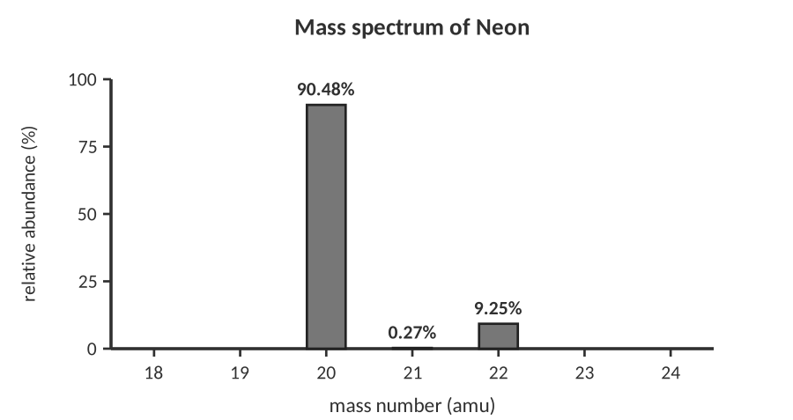
Mass spectrum of a sample of neon.
5. Use the graph to calculate the average atomic mass of neon (use whole-number isotope masses).
20 × 0.9048 = 18.096; 21 × 0.0027 = 0.057; 22 × 0.0925 = 2.035; sum = 20.188

Answer (units & sig figs): 20.19 amu
6. Gallium has two natural isotopes, Ga-69 (60.11%) and Ga-71 (39.89%). Calculate the average atomic mass.
69 × 0.6011 = 41.476; 71 × 0.3989 = 28.322; sum = 69.80

Answer (units & sig figs): 69.80 amu
7. Silicon has three isotopes: Si-28 (92.23%), Si-29 (4.68%) and Si-30 (3.09%). Calculate the average atomic mass.
28 × 0.9223 = 25.824; 29 × 0.0468 = 1.357; 30 × 0.0309 = 0.927; sum = 28.11

Answer (units & sig figs): 28.11 amu
8. A new element “Chemium” (Cm) has two isotopes: Cm-50 (mass 50 amu) and Cm-52 (mass 52 amu). Its average atomic mass is 50.6 amu. What is the percent abundance of each isotope?
Let x = abundance of Cm-52 (decimal): 50(1 − x) + 52x = 50.6 → 50 + 2x = 50.6 → x = 0.30
Cm-52 = 30%, Cm-50 = 70%

Abundances: Cm-50: 70%; Cm-52: 30%
9. Two students are asked for the atomic mass of sodium, which is 22.99 amu. Student A says a single sodium atom has a mass of 22.99 amu. Student B says that is the average of all natural sodium atoms and that nearly all of them are Na-23. Who is more correct? Use the idea of isotopes.
Student B. Sodium has essentially one natural isotope (Na-23, 100%), so the average is very close to 23. Student A’s statement would only be exactly true if every atom had exactly that mass, which isn't the case for any element.

D. The mole
10. How many atoms are in 0.250 mol of aluminum?
Use the mole bridge: grams ⇄ moles ⇄ atoms.

Answer (units & sig figs): 1.51 × 10²³ atoms Al
11. How many moles are in 3.01 × 10²⁴ atoms of calcium?
Use the mole bridge: grams ⇄ moles ⇄ atoms.

Answer (units & sig figs): 5.00 mol Ca
12. What is the mass of 2.40 mol of magnesium? (24.31 g/mol)
Use the mole bridge: grams ⇄ moles ⇄ atoms.

Answer (units & sig figs): 58.3 g Mg
13. How many moles of iron are in 100.0 g of iron? (55.85 g/mol)
Use the mole bridge: grams ⇄ moles ⇄ atoms.

Answer (units & sig figs): 1.791 mol Fe
14. How many atoms are in 10.0 g of helium? (4.003 g/mol)
Use the mole bridge: grams ⇄ moles ⇄ atoms.

Answer (units & sig figs): 1.50 × 10²⁴ atoms He
15. What is the mass of one atom of gold, in grams? (196.97 g/mol)
Use the mole bridge: grams ⇄ moles ⇄ atoms.

Answer (units & sig figs): 3.27 × 10⁻²² g per atom
16. Which has more atoms: 1.00 g of lithium or 1.00 g of lead? Explain without calculating.
Lithium. It has a much smaller molar mass (6.94 vs 207.2 g/mol), so 1.00 g of Li is far more moles, and therefore more atoms.

17. A student claims: "A mole of helium has a mass of 6.022 × 10²³ g." What mistake did the student make?
They confused Avogadro’s number (a count of particles) with mass. A mole of helium is 6.022 × 10²³ atoms and has a mass of 4.003 g.

E. Lab data analysis
LAB CORNER • Finding the average mass of an “element” in a bag of beads

A teacher hands out a bag containing round beads of three different masses. Students sort and weigh the beads.
Bead type | Number of beads | Mass of one bead (g)
Red | 42 | 0.85
Blue | 35 | 0.90
Green | 23 | 0.95

18. Calculate (a) the percent abundance of each bead type, and (b) the average mass of a bead.
(a) Red 42%, blue 35%, green 23% (100 beads total).
(b) 0.85(0.42) + 0.90(0.35) + 0.95(0.23) = 0.3570 + 0.3150 + 0.2185 = 0.8905 g

Average bead mass: 0.890 g
19. The students then weigh a large pile of the same beads and get 1.20 kg. Use the average mass to estimate the number of beads. How is this like using molar mass?
1200 g ÷ 0.890 g/bead ≈ 1.35 × 10³ beads (about 1,400). It's the same idea as using molar mass to convert mass to number of atoms: use an average mass per particle.

[ IMAGE GOES HERE ]
Optional: AP-style figure of a mass spectrometer, or a photo of a balance reading

TOPIC  ★ | Unit 1 Review  Put it in your own words before the test

1. Explain in two or three sentences what an isotope is and how it is different from an ion.
An isotope is an atom with the same number of protons but a different number of neutrons than another atom of the same element. An ion is an atom with a different number of electrons than protons, so it has a charge. Isotopes differ in mass; ions differ in charge.

2. Why did Rutherford’s experiment require a new model of the atom? What did the plum-pudding model predict, and what actually happened?
Plum pudding predicted that all alpha particles would go straight through. Instead, a few were deflected and a very few bounced back. That could only happen if the positive charge and the mass are concentrated in a tiny, dense nucleus.

3. Describe, step by step, how you would find the number of atoms in 25.0 g of an element. Include the two conversion factors.
grams → moles using the molar mass (1 mol = molar mass in g); moles → atoms using Avogadro’s number (1 mol = 6.022 × 10²³ atoms).

4. Complete the concept map: write each word in the correct circle and add a short phrase to each arrow. words: atom, nucleus, proton, neutron, electron, isotope, ion, mole
Sample: atom → has a nucleus (protons + neutrons) and electrons; protons define the element; change neutrons → isotope; change electrons → ion; mole counts atoms (6.022 × 10²³).

Sources & further reading
• AACT – The Hoopla About Atoms (atomic model activity) — https://teachchemistry.org/classroom-resources/the-hoopla-about-atoms
• Cornell CLASSE – Modeling Rutherford’s Experiment (lesson plan) — https://www.classe.cornell.edu/rsrc/Home/Outreach/LessonPlans/Modeling_Rutherfords_Experiment.pdf
• ChemEd X – Analogy Experiment: Projectile Pennies with Rutherford — https://chemedx.org/node/4143
• QuarkNet – Rutherford with Rolling Marbles teacher notes — https://quarknet.org/sites/default/files/RwRTeacherNotes_linkfix_kc28aug2017.docx
• AACT – Isotopes Make Cents (pennies as isotopes) — https://teachchemistry.org/classroom-resources/isotopes-make-cents
• SERC – Investigating Isotopes and Average Atomic Mass Using Pennies — https://serc.carleton.edu/sp/mnstep/activities/35527.html
• SERC – Using M&M’s as a model for average atomic mass — https://serc.carleton.edu/sp/mnstep/activities/20116.html
• Boston University GK-12 – Understanding Moles lesson — https://www.bu.edu/gk12/jason/understandingmoleslesson.html
• Northwestern CT-STEM – What is a Mole? — https://ct-stem.northwestern.edu/curriculum/print/251

